1.What is the purpose of a .gitignore file in a Git repository, and how does it contribute to managing project files?

Answer.gitignore tells git which files it should ignore. Its usually used to avoid commiting transient files from your working directory that aren’t useful to other collaborators,such as compilation products,temporary files etc. The purpose of gitignore files in managing project files is that is to ensure that certsin file not tracked by git remain untracked

2. Can you explain the syntax used in a .gitignore file to specify which files and directories Git should ignore? Provide examples of common patterns used.

Answer:- The names of the files which we want to be ignored are written in the .gitignore file as shown in the screenshot below.

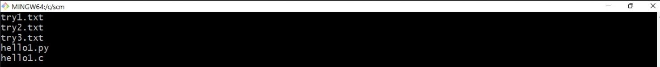

Here we have ignored files named try1.txt, try2.txt, try3.txt , hello1.c , hello1.c

If we want to ignore all files of similar type say .(extension) we use \*.(extension) instead of writing names of all the files.

****

3. How can you create a .gitignore file in a Git repository using Git Bash? Describe the steps involved in creating and editing this file.

Answer:- 1.The syntax to make a .gitignore file is to write “touch .gitignore” in git bash.



2.To edit the file we have to write “vi .gitignore” to open vim editor so we can simply edit our files as per our needs.



4. Is it possible to have multiple .gitignore files within a Git repository, and if so, how does Git handle them? Explain any hierarchy or precedence rules that apply when multiple .gitignore files are present.

Answer:- yes, Is it possible to have multiple .gitignore files within a Git repository,

If we want to ignore multiple file at a time so we have to just write “\*.extention of file”

then every file of that extention will be ignored by git.

